**Topic discussed in 1st session:**

1. Create user
2. Change user password
3. Change user time zone
4. View: kanban view, list view, form view
5. Search with/without filter
6. Advance search
7. Manage dashboard

**Topic discussed in 2nd session:**

1. http://screencast.com/t/1azC7WYtDatabase management
   1. Create
   2. Duplicate
   3. Drop
   4. Backup
   5. Create blank database for testing purpose
2. Workflow
   1. What is work flow
      1. I f we want to adapt a process then this is workflow
   2. How we view workflow from odoo
      1. Settings-> workflow-> view as diagonal
   3. There is two types circle in workflow
      1. Ash color circle – Start and End point
      2. White color circle – other point
   4. Example:
      1. http://screencast.com/t/1azC7WYt
   5. How to edit workflow
      1. View workflow as list
      2. Click on that point you want to edit

**Topic discussed in 3rd session:**

Product:

Users can sale product or can sale service where service another types of product.

User can purchase product or can purchase service.

Inventory management depends on product. So product is the main module here.

In Odoo a product’s contain:

Name: Product name

Price: product price

On-hand: Real quantity

Forecasted: Forecasted= On-hand + incoming – outgoing

Example of forecasted: 1000 pen will be sale; got sale order where company will purchase 500 pen on-hand=500 and outgoing=1000 so Forecasted= 500+500-1000= 0.

Product type: There are 3 types product in Odoo

1. Stockable product
2. Consumable product
3. Service

For example in a garments sweater is the final goods. So for this garments Sweater is stockable and yarn is consumable product.

Marker can be consumable product for a school but for a marker produce company marker is the stockable product. It is vary depend on company.

A software company is a service provider company.

Screen shot of product in below:

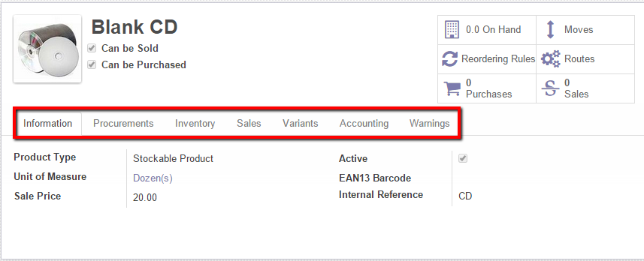

**Information:**

Unit of measure: Can be Dozen, cm, km, inch, lb etc where unit of measure category is the base of unit of measure.

There are 5 types Unit of measure category: Unit, weight, working time, Length/Distance, Volume

**Procurements:**

Cost price: Cost price depends on customer. Some customer sale with last price rate and some customer sale with avg. price rate.

**Variants:**

Variants are attributes. For example t-shirt has different size M, XL, S, Pizza has different size 8inch, 12inch, ball-pen has different color black, red, blue. Different size or color is the product attribute

Create a product ball pen where attribute is color.

If we uncheck “can be sold” checkbox then this product is not come product search list where search filter= “can be sold”

<http://screencast.com/t/hZQpIBlT>

<http://screencast.com/t/sv1w4l1t>

**Topic discussed in 4th session:**

**Purchase**

**Purchase Quotation:** Company purchase product and store product in inventory. Before purchase company makes a Quotation:

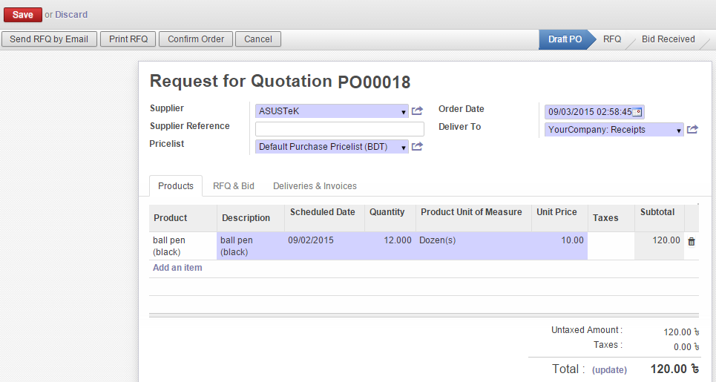

When we create purchase quotation it will not show into purchase order. When user submits quotation then this will appear in purchase order. Please check out below video link for better understanding.

<http://screencast.com/t/Ba5EchLmT4>

**Purchase order:** When company prepare purchase order then they ready for receive product. Then product transfer from supplier end to purchase company end and purchase is complete. Please check out below video link for better understanding.

<http://screencast.com/t/DRsFMuzx5r>

In general when company need to purchase product, company informs several supplier companies submit their quotations. Then they compare all quotation and call for bids. Purchase order given by procurement department but supplier gets their bill from accounts department.

**Topic discussed in 5th session:**

**Sales**

**Sales quotation & sale order:** When user wants to sale product at first they have to select customer then they select product and then they create sale quotation. When users confirm sale quotation then sale quotation converted to sales order.

When sales order created then user create invoice for the product and then product is ready for transfer to customer. After creating invoice user cannot edit invoice, if s/he wants to change invoice then s/he has to cancel this sales order and need to create new sale order.

Please check out below video link for better understanding.

[**http://screencast.com/t/9ZEd7VYXHar**](http://screencast.com/t/9ZEd7VYXHar)

**Topic discussed in 6th session:**

**Warehouse**: Generally people store product in a warehouse but in odoo warehouse is all about product location. For example a garment has 1000 buttons inside store house. Sewing department has 500 buttons iron department has 30 shirt where each shirt contain 8 buttons. So iron department has (30*8)240 buttons, storehouse has (1000+500+240) 1740 buttons. In odoo each department is define as warehouse where storehouse is parent and other departments are child and this is called **Chained Location.**

In odoo warehouse system 3 types product transfer occurred: Receive product, internal product transfer and product delivery. Odoo warehouse view:

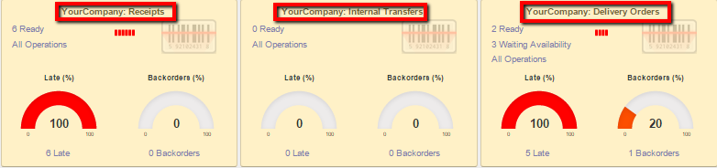

Product stock in means **Receipt** Product from supplier**, internal transfer** means product transfer one department to another department internally, When company deliver product to customer then this is called **Delivery order**

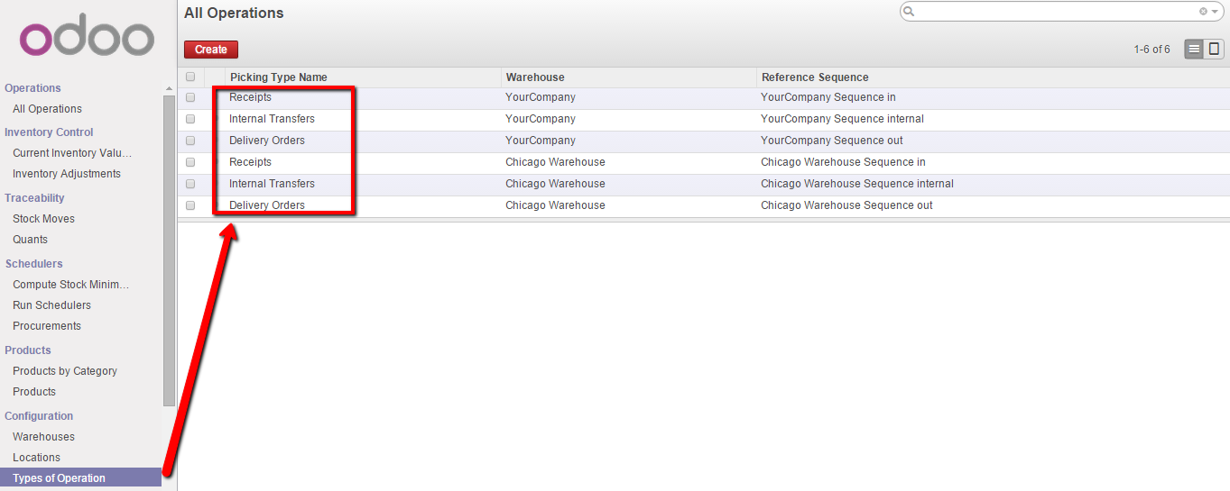

**Product stock in**: When supplier supply their product then product store into storehouse which is known as **product stock in**.

Also when product supply internally from one department to another department or else any department purchase product from a supplier this is also knows as product stock in.

**Product stock out:** When product delivery to customer then this is called **Product stock out.**

**Warehouse management introduction:**

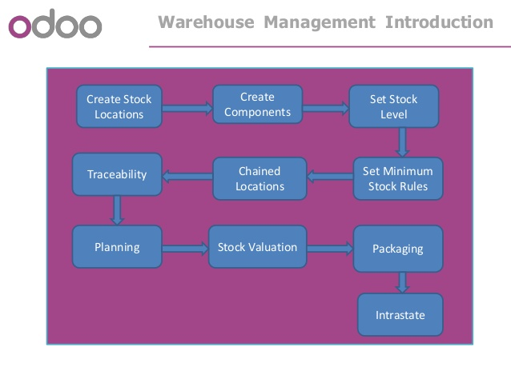

1. **Create stock location:** User can create warehouse from warehouse create button:

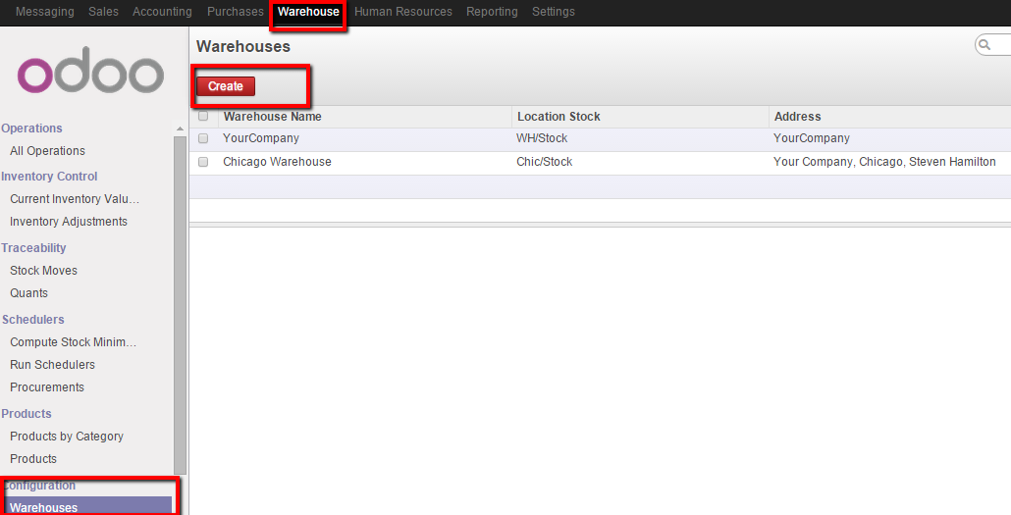

1. **Create component:** User have to create product for warehouse:

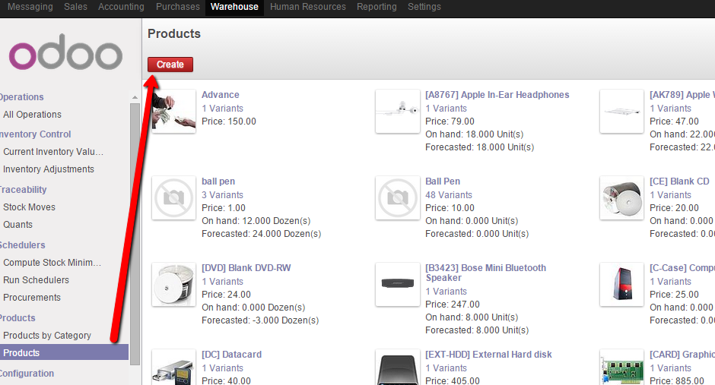

1. Set stock level and set minimum stock rules:

User can set stock level from inventory section: <http://screencast.com/t/cmOJPQzr>

User can set minimum stock rules that means when stock value reach minimum level it will give alert to user.

1. Chained Location: storehouse is parent and other departments are child and this is called **Chained Location.**
2. Traceability: Keep information to whom and where product is delivered.
3. Planning: What type of product have to buy next.
4. Stock valuation:
5. Intrastate: Inventory adjustment

**Topic discussed in 6th session:**

**Authorization:** In odoo we can create group which group can be used my multiple domain people.

For creating a group we have go to settings then select group:

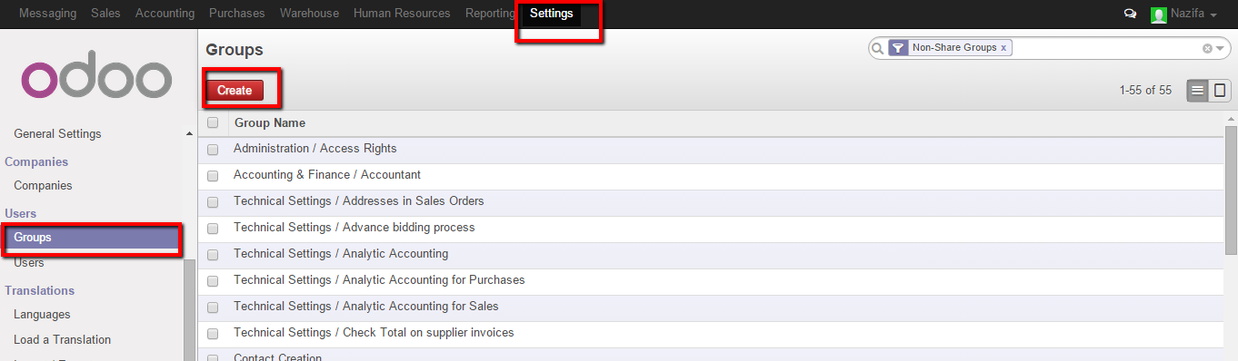

<http://screencast.com/t/5x44fuN8>

After creating a group user then user log in as user= nazifa, password=a and set that group user ([testing@testing.com](mailto:testing@testing.com)) password from settings.

<http://screencast.com/t/3nkuc9SLM>

Log in as user [testing@testing.com](mailto:testing@testing.com) where pass=a but